Information on tourist spots around Ojiya

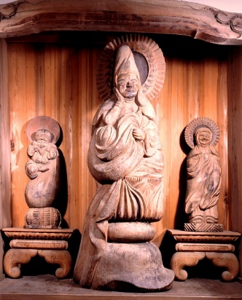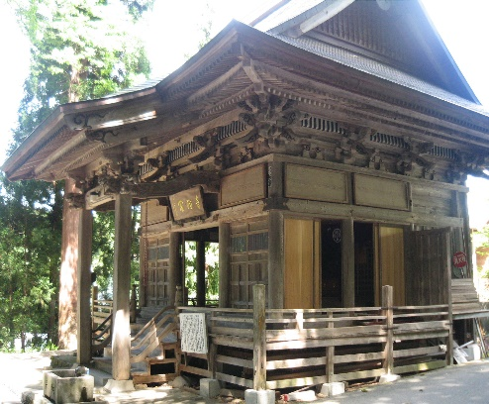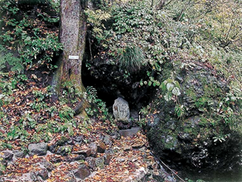

Koguriyama-Mokujikikannon hall/Otowa waterfall

Do you know of monks called “Mokujiki-shōnin”? They practiced teachings of the Buddha eating nuts and herbs. Most of them were from where Yamanashi prefecture is now located.

In 1803, one of the mokujin-shōnin engraved the 35 statues in Koguriyama-mokujikikannon Hall. There are 33 Kannon (the goddess of mercy) statues. Also, there are statues of Gyoki Bosatsu and Daikokuten.

When he came to Koguriyama for the second pilgrimage, he decided to engrave statues for the hall which had burned down and was rebuilt. He made all 35 statues from a big ginkgo tree in the village spending only 24 days. He was 86 years old at the time.

Those statues he made have smiley faces with chubby cheeks, and they’re called “Smiley Kannon”. They will make you feel peaceful.

A long time ago, kids were playing house with the statues in their hands, so the statues are all shiny now. If you want to try holding them yourself, you can make a reservation to do so.

In 1968, Koguriyama-Mokujikikannon Hall was designated as a Niigata Prefectural Important Cultural Property. It has been preserved by local people for a long time. On the 17th of every month, except snow season, the door is opened to public.

There is a waterfall called “Otowa waterfall” by the hall, and it is said salamanders which only live in a clear and fresh water live in this water.

